Arctic IERP genetics ID corrections

This table shows the results of genetic testing of the beam trawl data. One large issue is the number of fish that we identified as Arctic cod in the field in 2019 that were identified as pollock by genetics.



This figure shows the percent of genetically tested fish which were Identified as Arctic cod in the field, but as pollock by genetics tests, by length. Apparently we were better at identifying pollock when the fish were larger. These are only 2019 data.



These are the locations of the fish that were identified as arctic cod, but genetics IDd as pollock. Also shown are the numbers of genetically confirmed Arctic cod at each station, and the number of fish which were identified as arctic cod in the field, but not tested with genetics.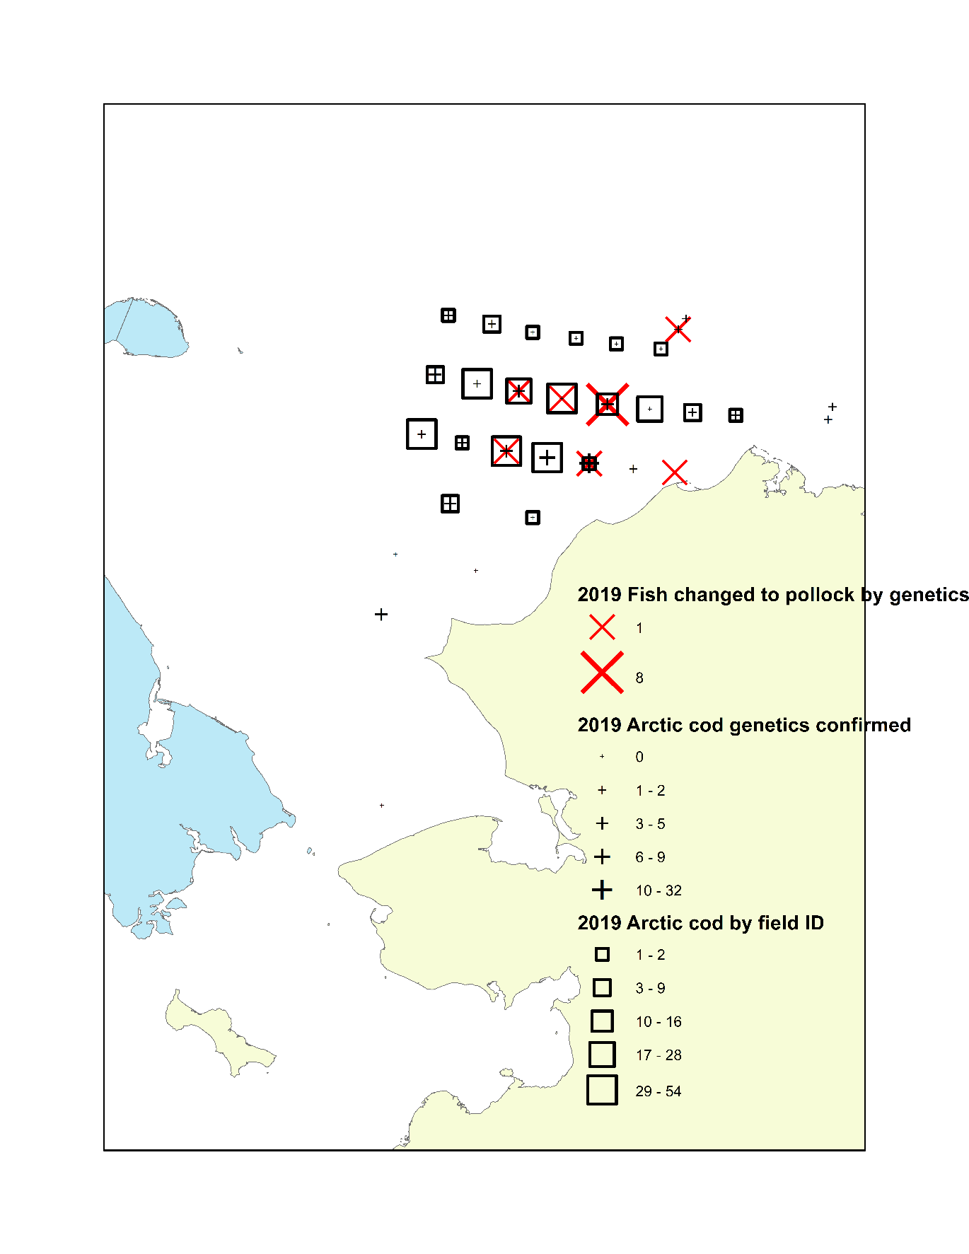

And here is a similar map for 2017.

